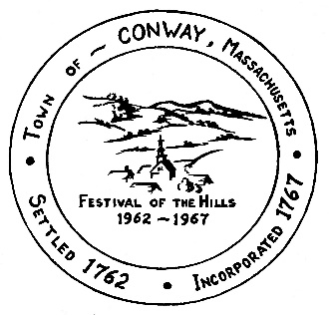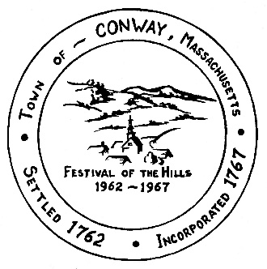

**Town of Conway, Massachusetts**

**Office of the Town Administrator**

P.O. Box 240, Conway, MA 01341

Town Office: 32 Main St. · Town Hall: 5 Academy Hill Rd.

Phone (413) 369-4235, ext. 3 · (413) 369-4237 Fax

*townadmin@conwayma.gov*

SUSTAINABILITY COMMITTEE

DATE: Thursday, June 26, 2025

TIME: 5:30 – 7:00 pm

LOCATION: Back room of Town Office

AGENDA:

1)  Approve minutes of May 29, 2025

2)  Selectboard meeting - report back: Selectboard expectations

3) Streetlights project discussion - guest, David Chandler, Ashfield

3) Town building audit, Grammar School walk through

4) July and August SC meetings - schedule

5) RTE – maintenance contract

6) Ongoing, future business, includes{ Solar projects – school roof, safety building, garage;  Website, SC page – links, information, public presentations

7)  New business

Meetings:

School tour - Friday, June 27