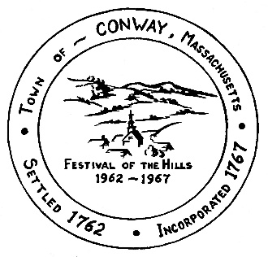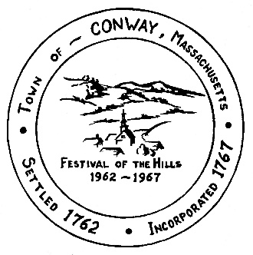

**Town of Conway, Massachusetts**

**Office of the Town Administrator**

P.O. Box 240, Conway, MA 01341

Town Office: 32 Main St. · Town Hall: 5 Academy Hill Rd.

Phone (413) 369-4235, ext. 3 · (413) 369-4237 Fax

*townadmin@conwayma.gov*

SUSTAINABILITY COMMITTEE

DATE: Thursday, November 14

TIME: 5:30 – 7:00 pm

LOCATION: Back room of Town Office

AGENDA:

* 1. Approve minutes of October 17, 2024
  2. Streetlights in town – RTE streetlights audit, map, timeline
  3. Green communities - next steps, summit meeting
  4. Grammar school – letter to Superintendent
  5. Public presentations – winter 2025
  6. Future meeting dates
  7. Updates/new business

Zoom link

<https://us02web.zoom.us/j/7091130284?pwd=WjZhL2piaWw5aUxmaU0rVnREUTVQdz09&omn=81569873362>

Meeting ID: 709 113 0284

Passcode: Conway