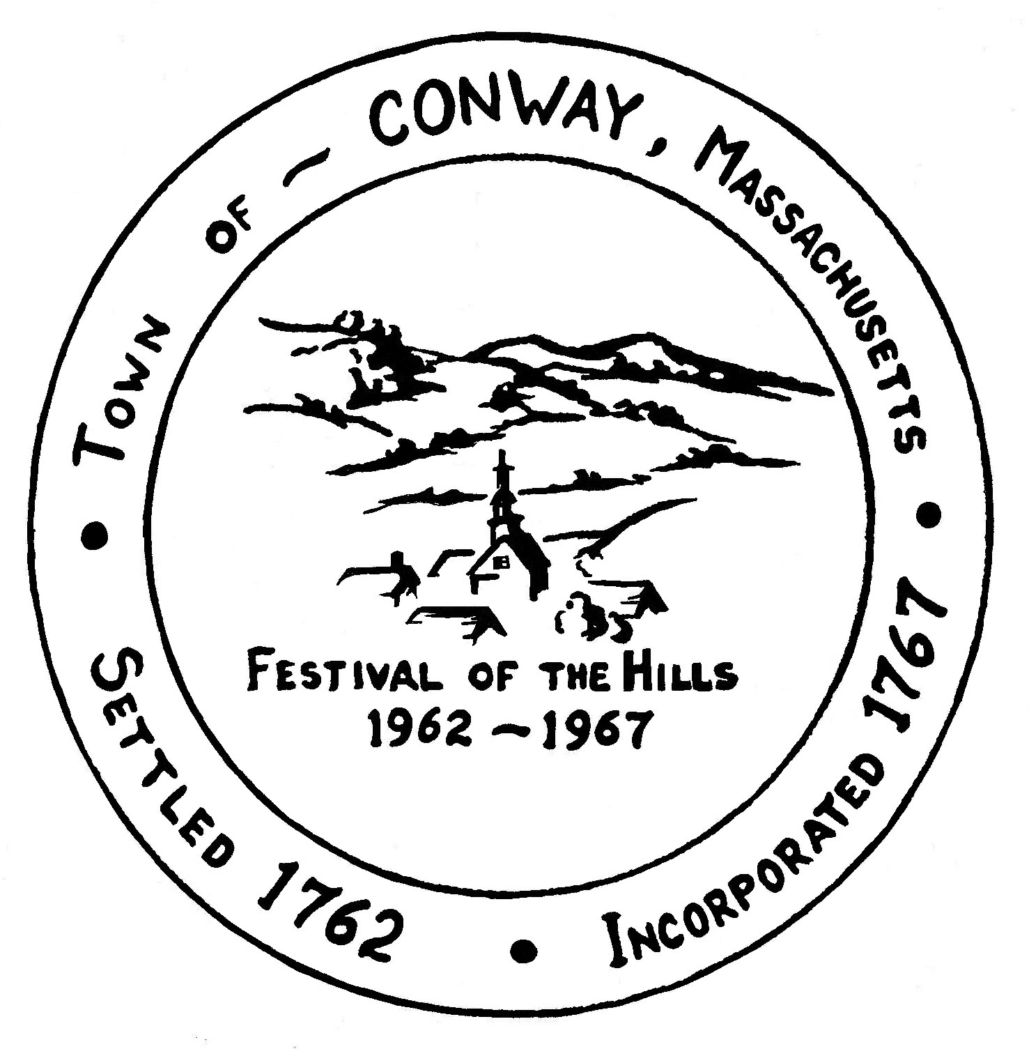
Town of Conway, Massachusetts

OFFICES TO BE FILLED AT
TOWN CAUCUS 2023

Thursday, March 16, 2023
6:00 pm
at Town Hall, 5 Academy Hill Road

Conway holds an annual Caucus for the purpose of nominating candidates for the Annual Town Election. The names on this list are the people currently holding the positions listed, whether or not they are running for re-election will be determined at Caucus. Voters may also obtain nomination papers from the Town Clerk’s Office to collect signatures for a place on the ballot.

Office to be Filled | Incumbent | Term
Selectboard | Erica Goleman | 3 years
Board of Assessors | Roxanne Parent | 3 years
Board of Health | Mathilde Hunting | 3 years
Board of Health | Devon Whitney-Deal | 3 years
Local School Committee | Philip Kantor | 3 years
Local School Committee | Michael Merritt | 3 years
Moderator | James Recore | 1 year
Planning Board | Susan Fentin | 3 years
Planning Board | Beth Girshman | 3 years
Tree Warden | Walter Goodridge | 3 years

