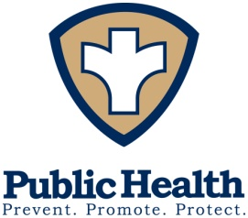
Conway Board of Health Meeting

Monday, November 8, 2021

6:00 p.m.

Town Hall

Time | Guest | Summary
6:00 pm
6:15 pm | Carl Nelke | Title V
6:30 pm | SelectBoard | Joint Meeting re: Mask Mandate
6:45 pm
7:00 pm

Agenda

- Review and approval of minutes from October 25, 2021 meeting.

- Sign Bills and/or Permit

- Title V Agent Report (C. Nelke)

- Health and Wellness (J Choate)
- MDPH updates, member activities, and general discussions
- Updates on vaccination distribution
- Review any current Covid19 Cases in Conway
- Any new COVID related developments
- Other Health and Wellness concerns

- Food Service and Inspections
- Related developments and Activities

- Other Business

- Unanticipated Items of concern

Notes:
Next regular meeting date will be November 22, 2021

* The listing of agenda items includes matters reasonably anticipated by the Chair to come under discussion at the meeting. Not all items listed may in fact be discussed and other items not listed may also be brought up for discussion to the extent permitted by law.

