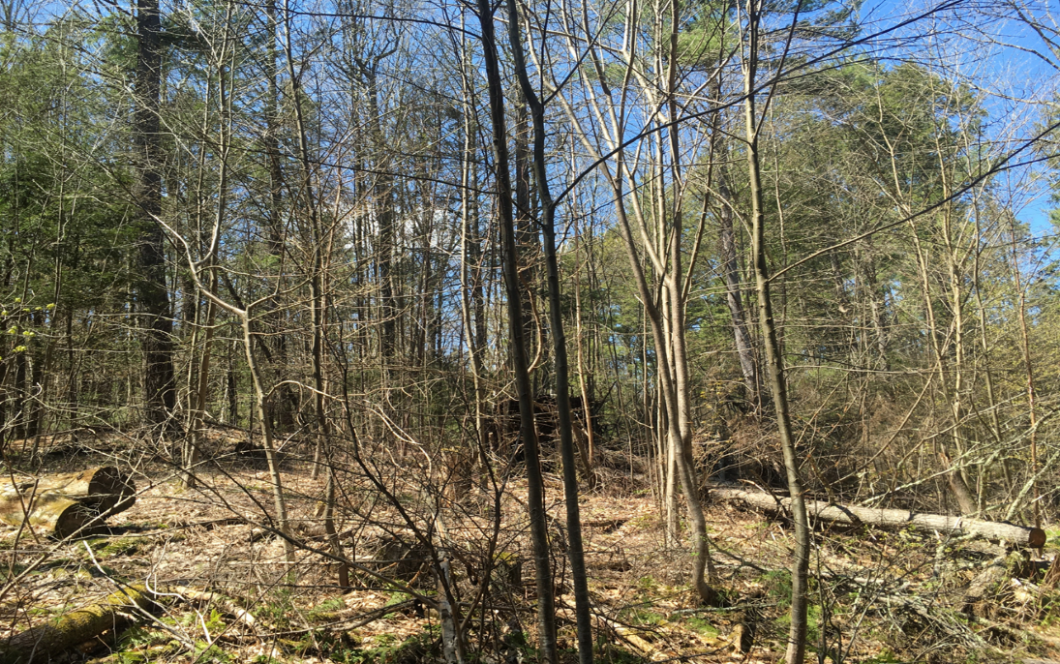

Conway Town Farm Forest Walk
June 18, 2022, 9:30am – 12noon
(rain date: June 19, 2022, same time)

You are invited to walk with local forester Mary Wigmore and DCR District Forester, Alison Hunter Wright through the 100-acre town-owned forest on Cricket Hill Road. They will lead a talk with your community about the forest’s resiliency and its vulnerabilities to the predicted impacts of climate change on the ecosystem. Come explore the structural complexity and biodiversity of this hilltop forest ecosystem and learn how it can function as a nature-based climate solution.
Please wear sturdy shoes and bring water and bug repellent (ticks are common) as the hike will cover approximately 2 to 2.5 miles on rough terrain and will take about 2 to 2.5 hours of your time.
Participants will be limited to 15 due to parking limitations and to ensure that everyone can hear the leaders. Call Mary Wigmore at 413-628-4594 to register. You can also register at this link: https://forms.gle/98tNQWfM8C9tuLLq5. Directions for the hike location and parking will be given upon registration.

